Configuring Internet access in Windows 10 on ESXI Host

1. Connect to your server and click on the Networking .

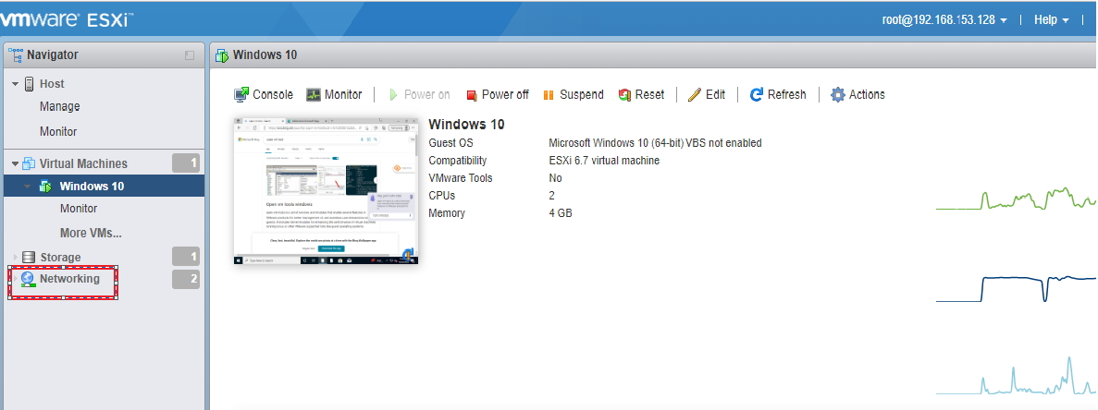

1. Click the Virtual Switches .

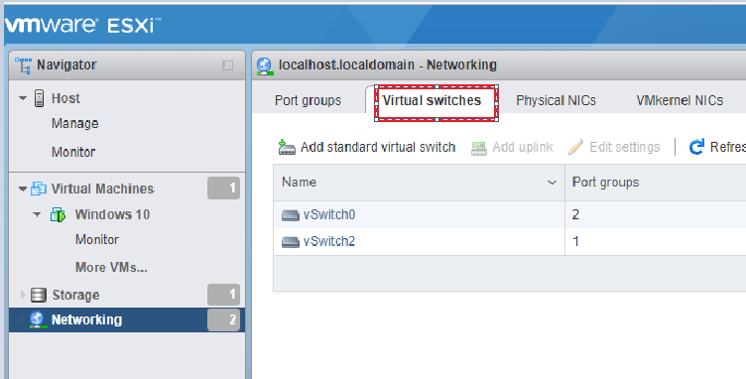

1. Click the Add standard virtual switch .

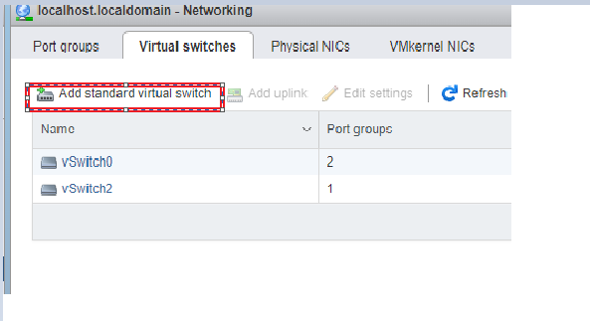

1. Click the Add standard virtual switch .
2. Add vSwitch Name - vSwitch2 .
3. Add uplink - vmnic2 – up, 1000 mbps .
4. Then Click Add .

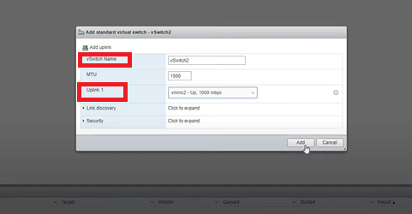

1. Click on Port group and SELECT “ ADD Port Group “ .
2. ENTER Name – Internett .
3. SELECT Virtual Switch – Vswitch2 and Click on ADD .

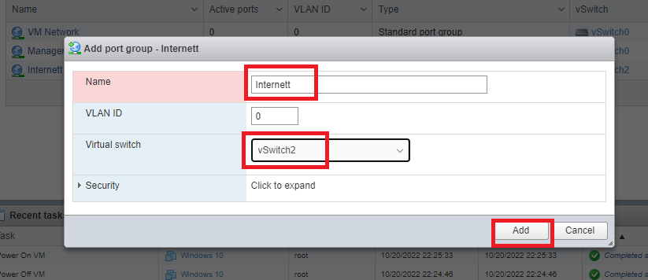

1. After Port Group Add , Show like this .

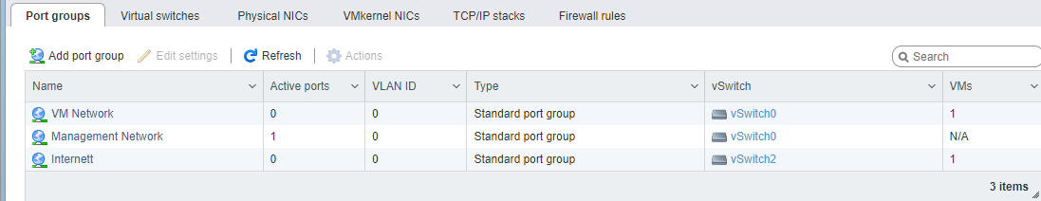

1. Click on Virtual machine -> Actions -> Edit settings -> Add network adapter .
2. SELECT “ Network adapter “ and choose - Internett .
3. Press SAVE .

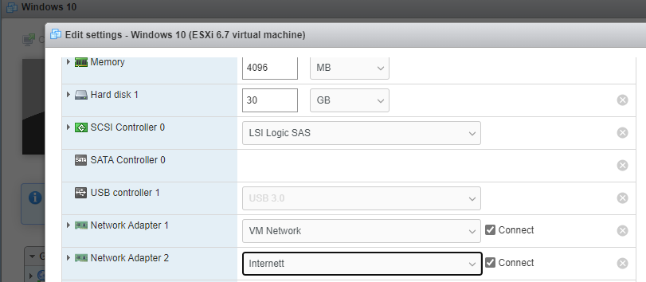

1. START the Windows 10 VM .



